Practical-4: INDEXING USING Mangodb

**Date:-17/01/2024 Submission Date:- 24/01/2024**

**Write-up: -**

* Indexing in mongodb
* Types of indexing
* Document document-oriented NoSQL

1. Mongo DB indexing

a. Create index in Mongo DB

b. Finding the indexes in a collection

c. Drop indexes in a collection

d. Drop all the indexes

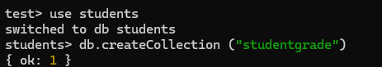

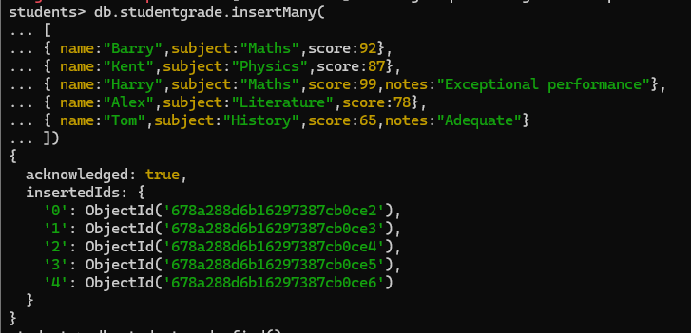

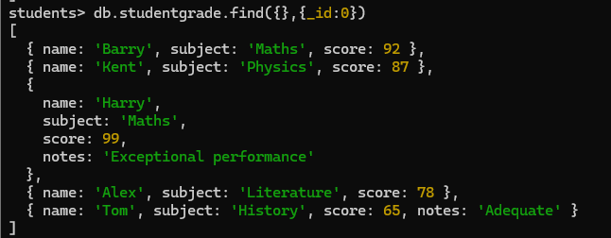

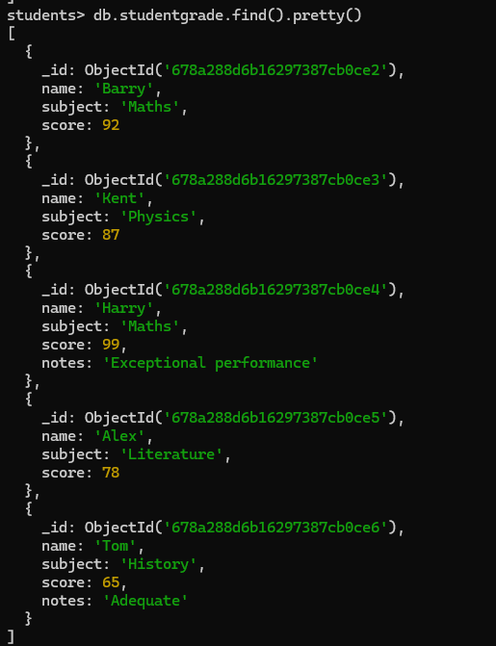

**Indexing:**

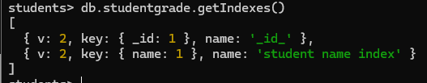

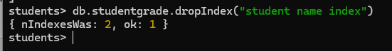

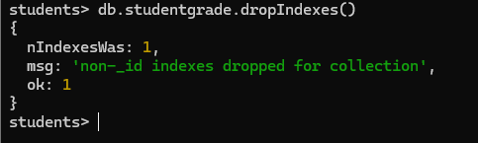

2. Create all the types of indexes (discussed in class) which will help in finding certain words in a document by using AIRPORT (dataset).

